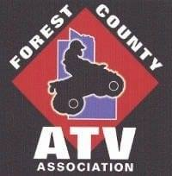
Forest County ATV Association March 2026
P. O. Box 331
Laona, WI 54541

Connect with us via:
Email: forestcountyatv@gmail.com
Website: https://forestcountyatv.com
Facebook: @ForestCountyATVassociation

This is just a friendly reminder that your Forest County ATV Association (FCATVA) membership is due. You now have 2 options to renew:
- Update the form below, make check payable to FCATVA, return to the address listed above, update information
- Use the QR Codes below to pay with your credit card via SQUARE secure credit card processing

Family Membership ($30) | Single Membership ($20) | Business Membership ($50)
 |  | 
Going forward ALL memberships renew annually each January but will be due in April.

FCATVA appreciates your support; it enables us to:
- Open and maintain our routes and trails
- Purchase and maintain equipment for ongoing trail maintenance
- Install appropriate trail signage
- Education and training efforts
- Support local business sponsors
- Support Forest County charitable initiatives

FOREST COUNTY ATV ASSOCIATION MEMBERSHIP

Name (Both first names for family membership, Business Name and contact information for businesses)

Address

City, State & Zip

E-Mail Phone Date
Remember, we hold our club meetings the second Saturday of each month (March – October). Times and locations for the meetings are shared on the ForestCountyATVassociation Facebook page. We hope to see you there!
Sincerely,
Brandi Roberts, Membership Coordinator

